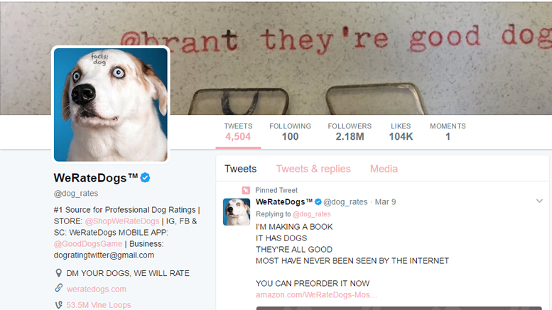

**Introduction**

The dataset used was a merger of a CSV document from Udacity provided by WeRateDogs, a TSV file programatically extracted and JSON text document provided by Udacity.

**Data Analysis**

This data analysis project will attempt to answer these questions: -

* What type of dogs are in the tweets (Depicting top 10 dogs)?
* Is there a relationship between ratings, favourite counts and retweets?
* What is the highest user tweet source?
* What dog image had the highest favourite count?
* What dog image had the highest retweet count?

**What type of dogs are in the tweets (Depicting top 10 dogs)?**

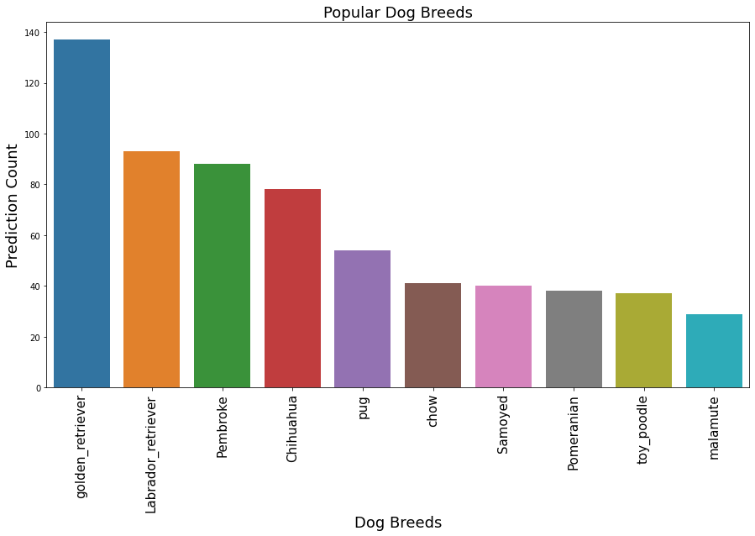

**Observation:** This plot shows that the Golder retriever is the most popular dog breed, followed by Labrador retriever and Pembroke.

**Is there a relationship between favourite_count and retweets?**

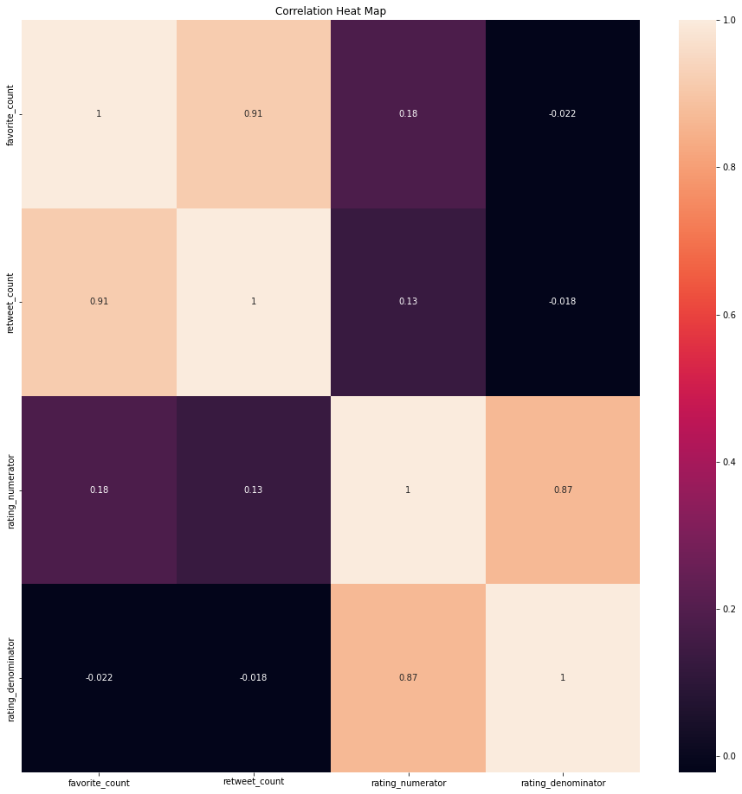

The heatmap shows our correlation relationships, showing a strong relationship between favourites and retweets with a correlation coefficient of approximately (r = 0.9).

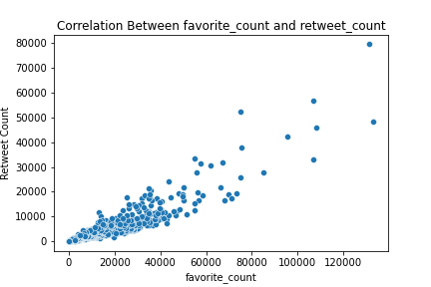

**Observations:** There is a strong linear relationship between Favourites and Retweets counts. This is not a strange thing because most people will favourite what they retweet and vice versa.

**What is the highest user tweet source?**

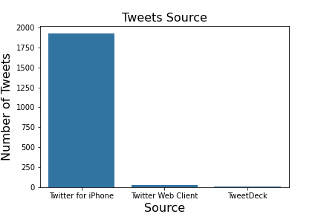

**Observation:** This shows that Iphone users had the highest tweets.

**Based on favourite count, This dog image had the highest rating.**

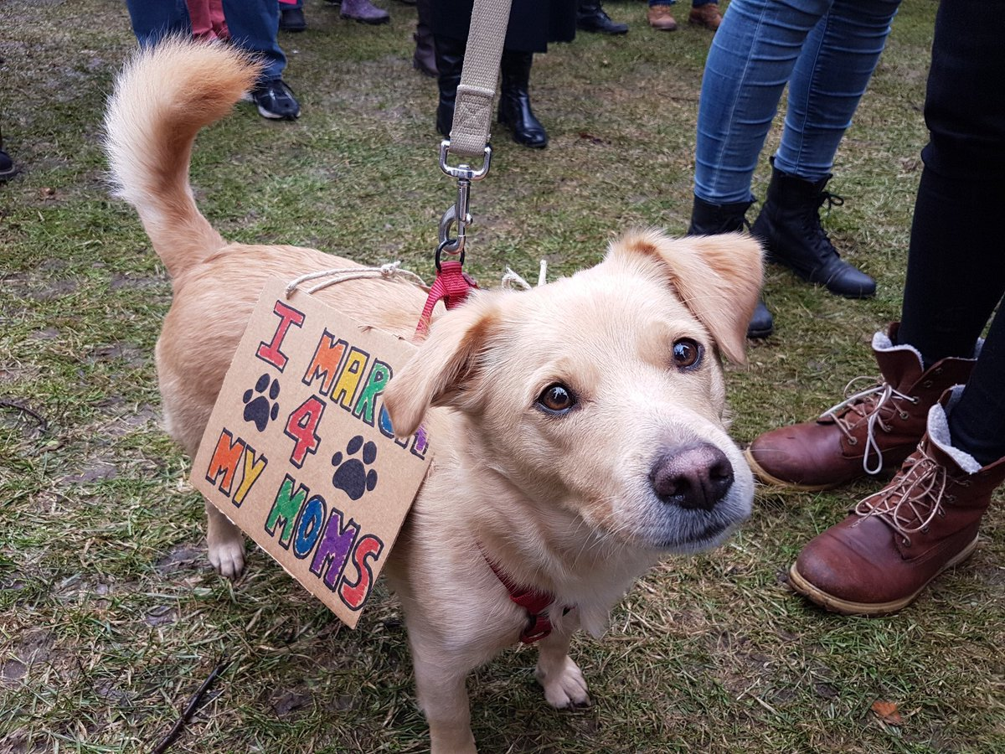

**Based on Retweet count, this dog had the highest number of retweets.**



**Conclusion**

* During our analysis, there is a **strong linear relationship between the number of Favourites and the number of Retweets** of a given Tweet. The regression coefficient for this relationship is 0.91.
* This plot shows that **Golder retriever** is the most popular dog breed, followed by Labrador retriever and Pembroke.
* This shows that Iphone users had the highest tweets.

**Reference**

<http://freedomcrossroads.com/2017/05/31/weratedogs-will-donate-merchandise-profits-planned-parenthood-updated/>